Exhibition Booth

Type | Partition | Pop-up Display
Price | RM3200 | RM5000
Size | 9.8’ (W) x 9.8’ (D) x 8’(H) | 8.5’ (W) x 7.2’ (H)
Per set complete with | - Info table - (1)  - Folding chair - (1)  - Dustbin - (1)  - Fascia name - (1)  - Plug point - (1) | - Curved Aluminium Structure (including the layout graphic/design which not amendment not more than 3 times) - (1)  - Lights - (2)  - Trolley Case - (1)  - Info table - (1)  - Folding chair - (1)  - Dustbin - (1)  - Plug point - (1)
Illustration  *the Image is being used for illustrative purposes only. | 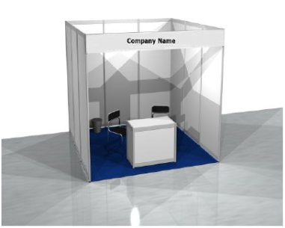 | 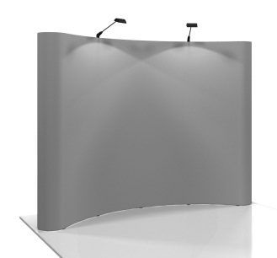

For booking and further information, please contact:
SFDCC 2016 Secretariat (Dr. Nor Akmar Abdul Aziz)
Tel: +603-89467209
Fax: 603-89432514
E-mail: kema_aziz@yahoo.com

