CURRICULUM VITAE

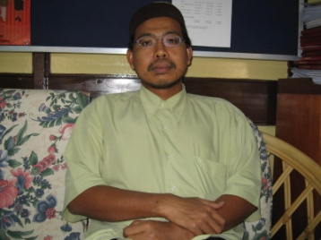 | Name | : | Dr. Mohamad Roslan bin Mohamad Kasim
 | Address | : | Department of Forest Management  Faculty of Forestry  Universiti Putra Malaysia  43400 Serdang  Selangor
 | Tel. | : | 03-89467221
 | Fax | : | 03-89432514
 | E-mail | : | mohdroslan@upm.edu.my

Academic Qualifications / Education
- Kedoktoran dalam bidang Hidrologi
- Sarjana Sains (Peningkatan Kualiti dan Produktiviti)
- Sarjanamuda Sains Statistik
Areas of Interest
- Environmental Statistics
- Environmental Modelling
- Water Quality
Professional Qualification / Membership / Affiliation
NONE
Appointments / Carrier
Position |  |  | Duration
1. Lecturer |  |  | 10 August 2005 - today
Awards
No. | Name of awards | Title | Award Authority | Award Type | Year
1. Bronze Medal PRPI UPM Academic 2005
2. Gold Medal PRPI UPM Academic 2007
3. Bronze Medal UTEMEX UTeM Academic 2013
4. Gold Medal RIID UiTM Academic 2013
5 Anugerah Khidmat Cemerlang UPM Career 2007
6. Anugerah Khidmat Cemerlang UPM Career 2013
CHECK LIST
NO | TYPE OF INFORMATION | NOTES
1. | Curriculum Vitae | As stated earlier
2. | ORCID | I don’t think I have this / Never notice
3. | Research Gate | Not active at all
4. | Google Scholar | NONE
5. | Facebook (Pilihan) | NONE
6. | Blog (Pilihan) | NONE
7. | Lain-lain (Pilihan) | NONE

